**Aim:** To demonstrate the configuration of default routes to the router.

**Topology:**

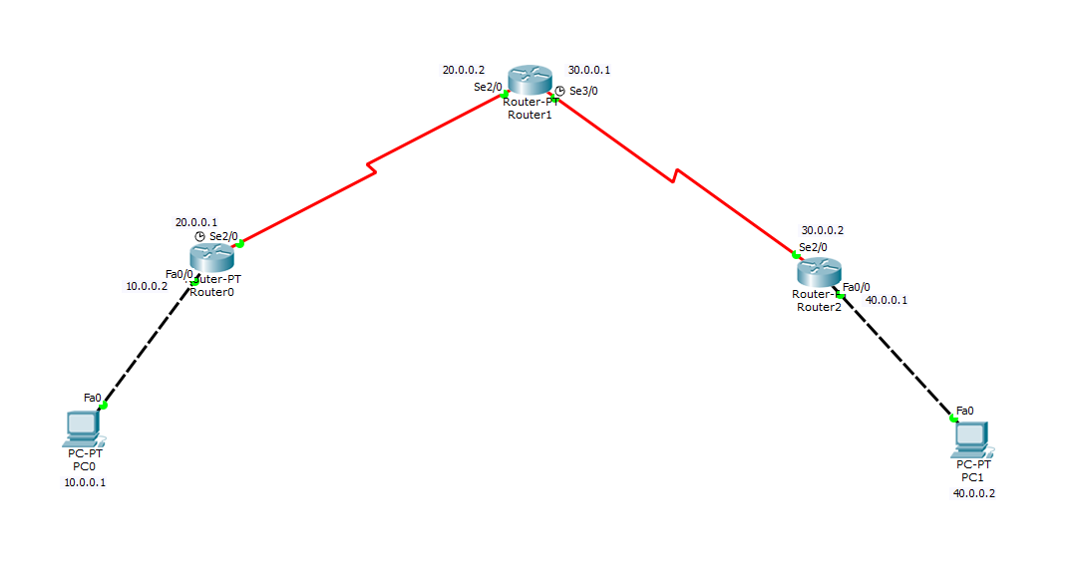

**Router_0 Configuration:**

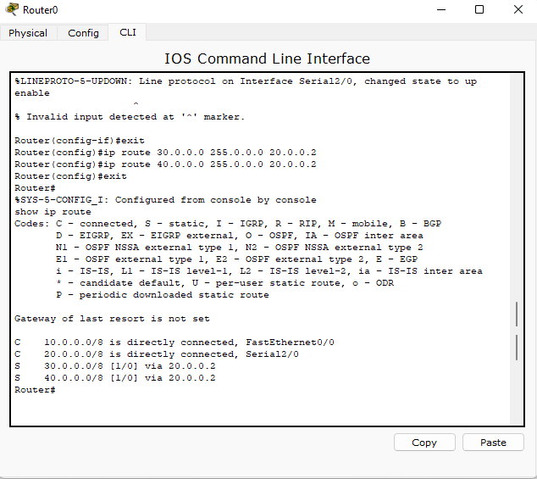

**Router_1 Configuration:**

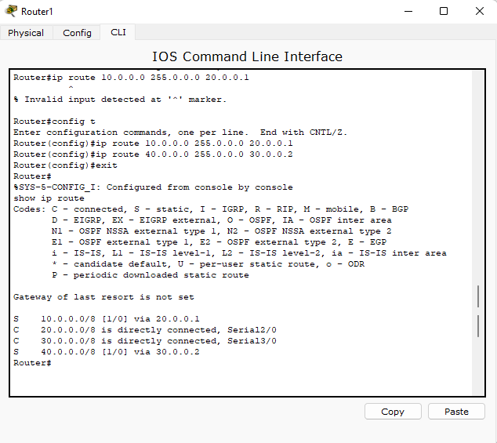

**Router_2 COnfiguration:**

